Poultry Nutri-Drench®
Increase Profits and Flock Production with Poultry Nutri-Drench!
Finally, results you can see!
Backed by 20 years of research, field trials and 2 U.S. Patents
Poultry Nutri-Drench is specifically formulated for all poultry. Our approach to promote overall health is to boost the immune system FAST! Nutri-Drench shunts directly to the bloodstream, eliminating the hours needed for digestion. Nutri-Drench can be measured in the bloodstream in minutes, with 99% utilization.
Superior, nutrient rich, high energy support.
No Digestion Required – Immediate Nutrient Balance delivers all vital nutrients to restore the immune system in minutes!
Get off to a faster, stronger start by increasing nutritional uptake!
- Appetite
- Poor Hatchability Laying Hens
- Weak Newborns
- Extreme Weather Conditions
- Shipping Strain
- Heat Stress Diarrhea
- Disease
- Vitamin Deficiencies
- Regular Preventive Care
- Energizes weak newborns
- Stimulates appetite
- Corrects diarrhea
- Maximizes antibiotic/vaccine response
- Balances immune system
- Quick energy for show.
All Benefit From Supplemental Nutrition
Balanced nutrition is important for growth, reproduction and resistance to disease. Stress can be caused by a number of factors, however, poultry hide problems very well until stress becomes critical. In all cases, fast replacement nutrition is important or poultry can go into shock and die.
Even disease is difficult to diagnose. When poultry begins to show obvious signs of illness, they are already seriously ill. Balanced, replacement nutrition should be used concurrently when antibiotics are administered.
Poultry Nutri-Drench® is the only supplement that does not require digestion. It is the fastest replacement nutrition possible, with 99% utilization.
STRESS DOSE:
AUTOMATIC PROPORTIONER MIXING INSTRUCTIONS:
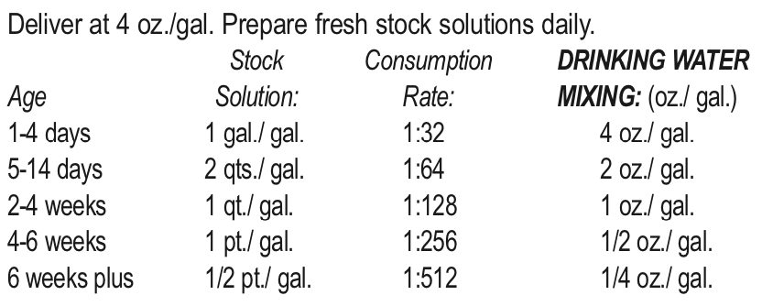
SHIPPING STRESS: Administer on arrival. Not necessary to use daily.
LONG TERM/MAINTENANCE DOSE: 2-5 mL (cc) per gallon of water, depending on weight of bird & climate temperature. Adjust as needed
Contains Only Natural Nutritional Ingredients
MONEY BACK GUARANTEE
INGREDIENTS:
propylene glycol, molasses products, calcium carbonate, choline chloride, DL-methionine, l-lysine, Vitamin E supplement, Vitamin A supplement, Vitamin D-3 supplement, thiamine, niacin, zinc sulfate, ethylenediamine dihydroiodide, magnesium sulfate, manganese sulfate, iron sulfate, copper sulfate, sodium selenite, cobalt sulfate, sugar

